JUnit_Basic Testing Exercises
Exercise 1: Setting Up Junit
JUnitSetupTest.java
import org.junit.Test;
import static org.junit.Assert.*;
public class JUnitSetupTest {
@Test
public void testAddition() {
int result = 2 + 3;
assertEquals(5, result);
}
@Test
public void testMultiplication() {
int result = 4 * 3;
assertEquals(12, result);
}
}

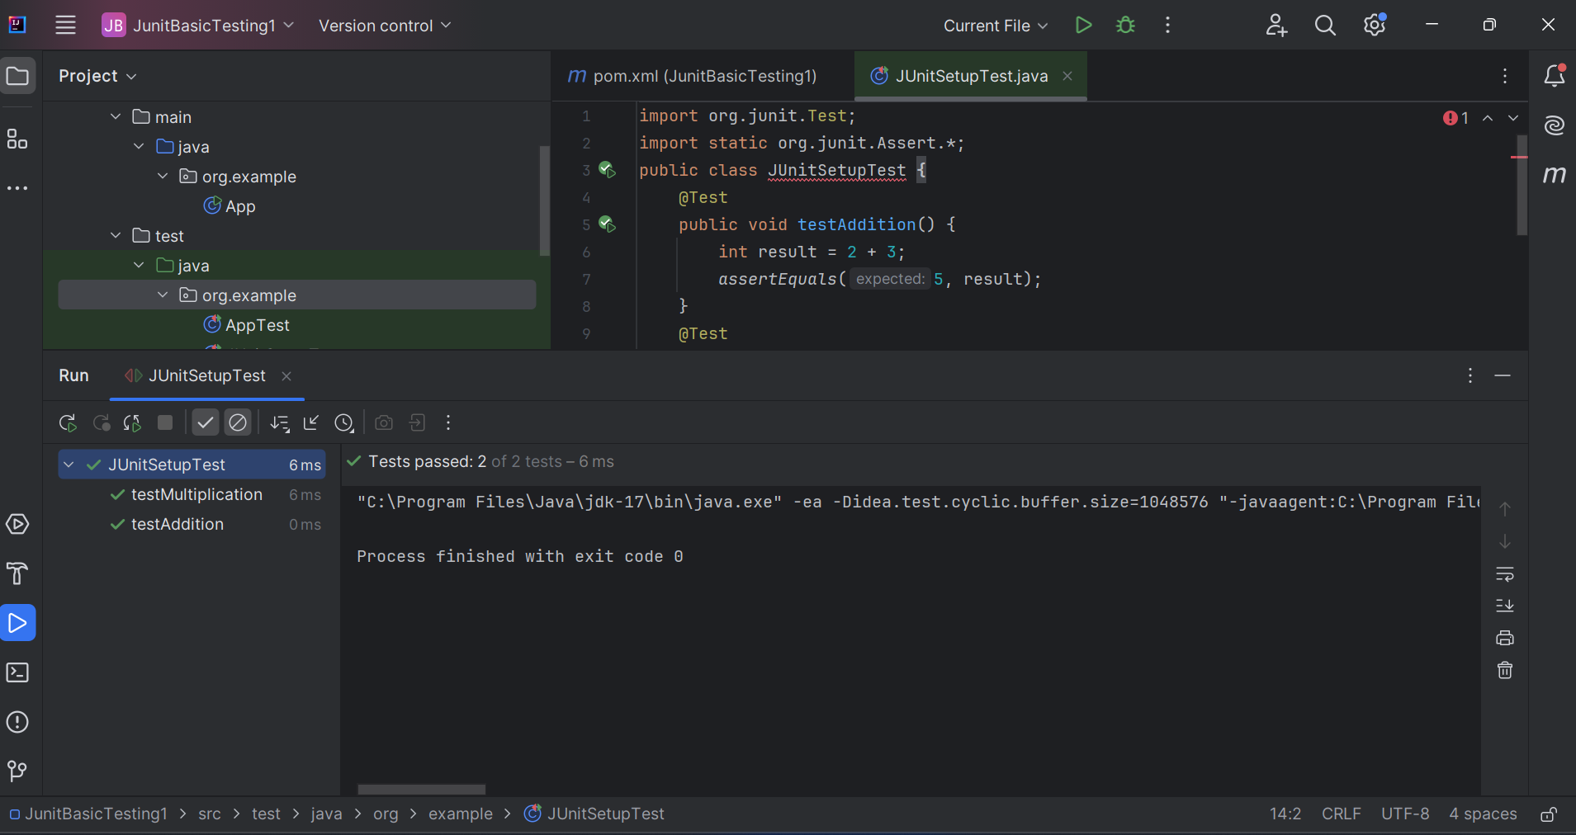

Exercise 3: Assertions in Junit
AssertionsTest.java
import org.junit.Test;
import static org.junit.Assert.*;
public class AssertionsTest {
@Test
public void testAssertions() {
// Assert equals
assertEquals(5, 2 + 3);
// Assert true
assertTrue(5 > 3);
// Assert false
assertFalse(5 < 3);

// Assert null
assertNull(null);
// Assert not null
assertNotNull(new Object());
}
}

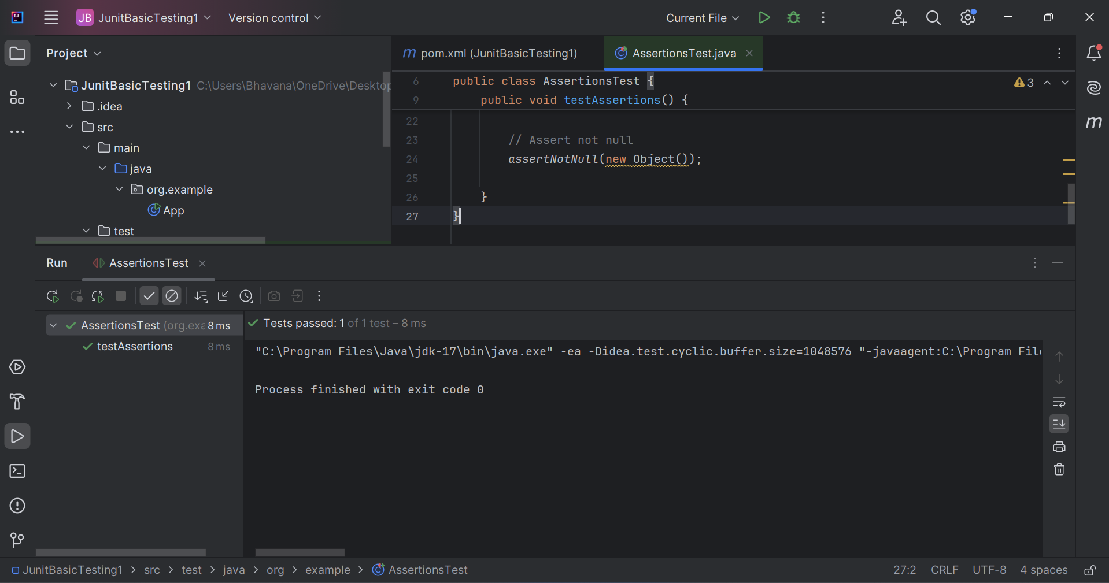
Exercise 4: Arrange-Act-Assert (AAA) Pattern, Test Fixtures, Setup and Teardown Methods in Junit
AAAPatternTest.java
import org.junit.Before;
import org.junit.After;
import org.junit.Test;
import static org.junit.Assert.*;

public class AAAPatternTest {

private int number1;
private int number2;

@Before
public void setUp() {
System.out.println("Setting up...");
number1 = 10;
number2 = 5;
}
@After
public void tearDown() {
System.out.println("Tearing down...");
number1 = 0;
number2 = 0;
}
@Test
public void testAddition() {
// Arrange
int expected = 15;
// Act
int result = number1 + number2;
// Assert
assertEquals(expected, result);
}
@Test
public void testSubtraction() {
// Arrange
int expected = 5;
// Act
int result = number1 - number2;
// Assert
assertEquals(expected, result);
}
@Test
public void testMultiplication() {
// Arrange
int expected = 50;
// Act
int result = number1 * number2;
// Assert
assertEquals(expected, result);
}
}

